Nikhil Satpute 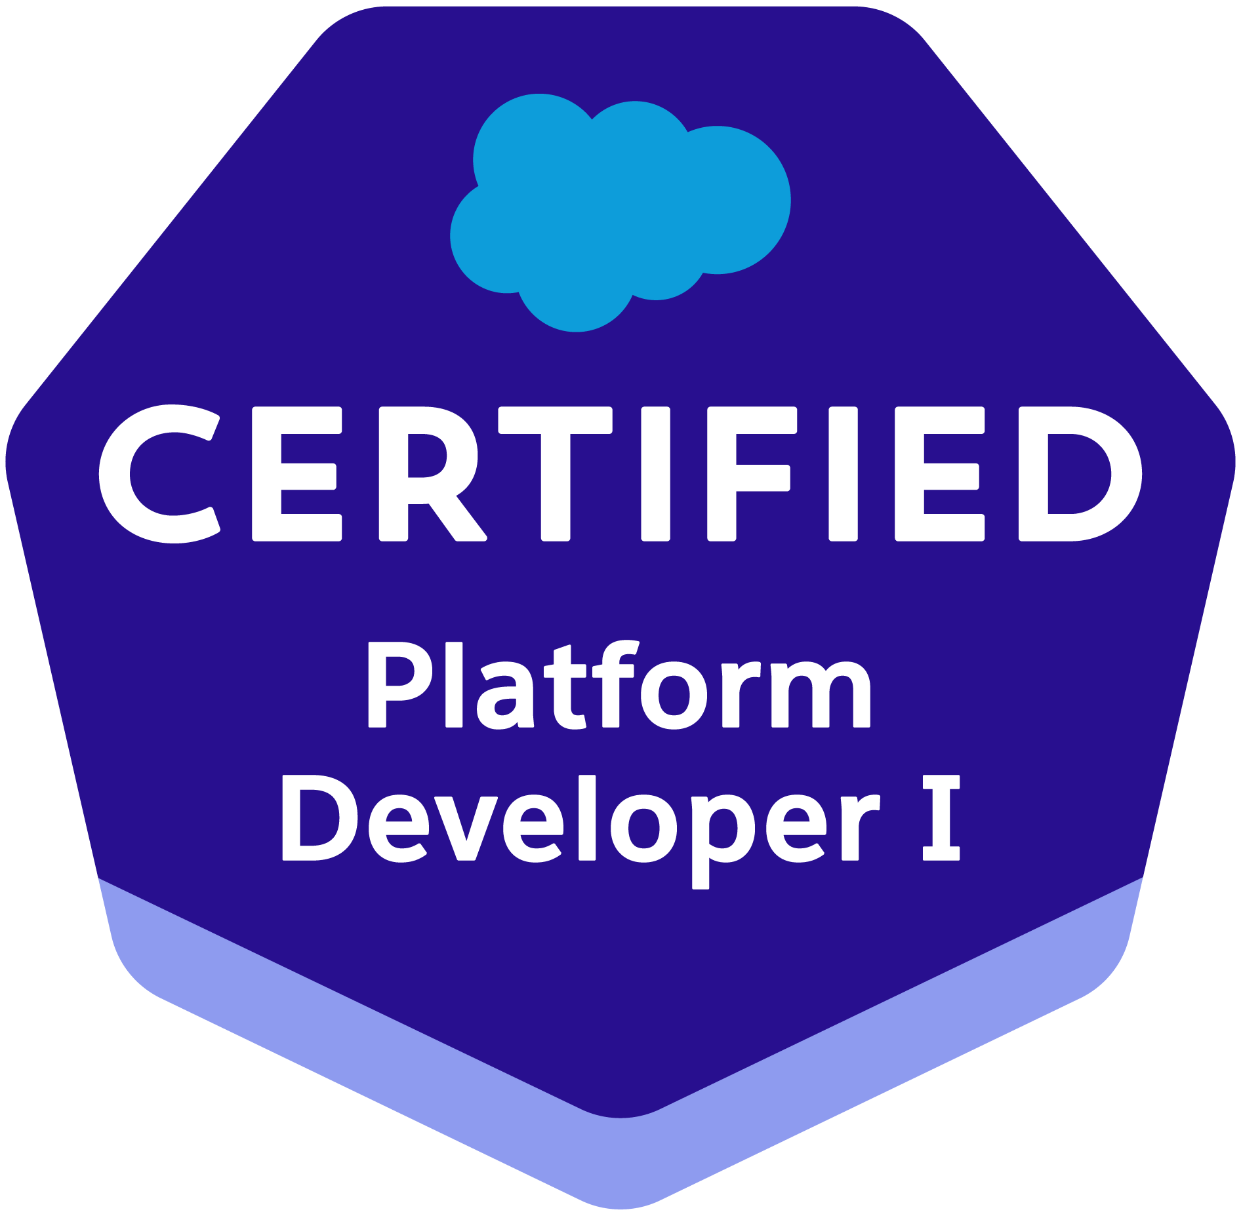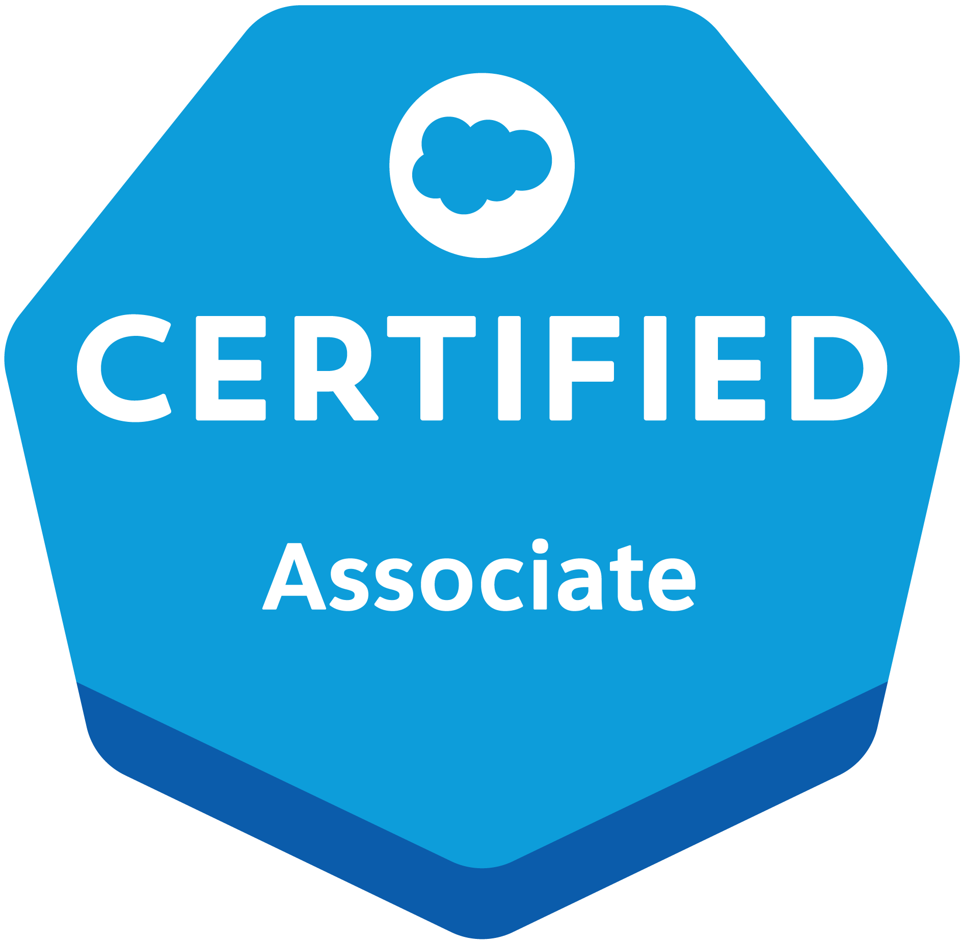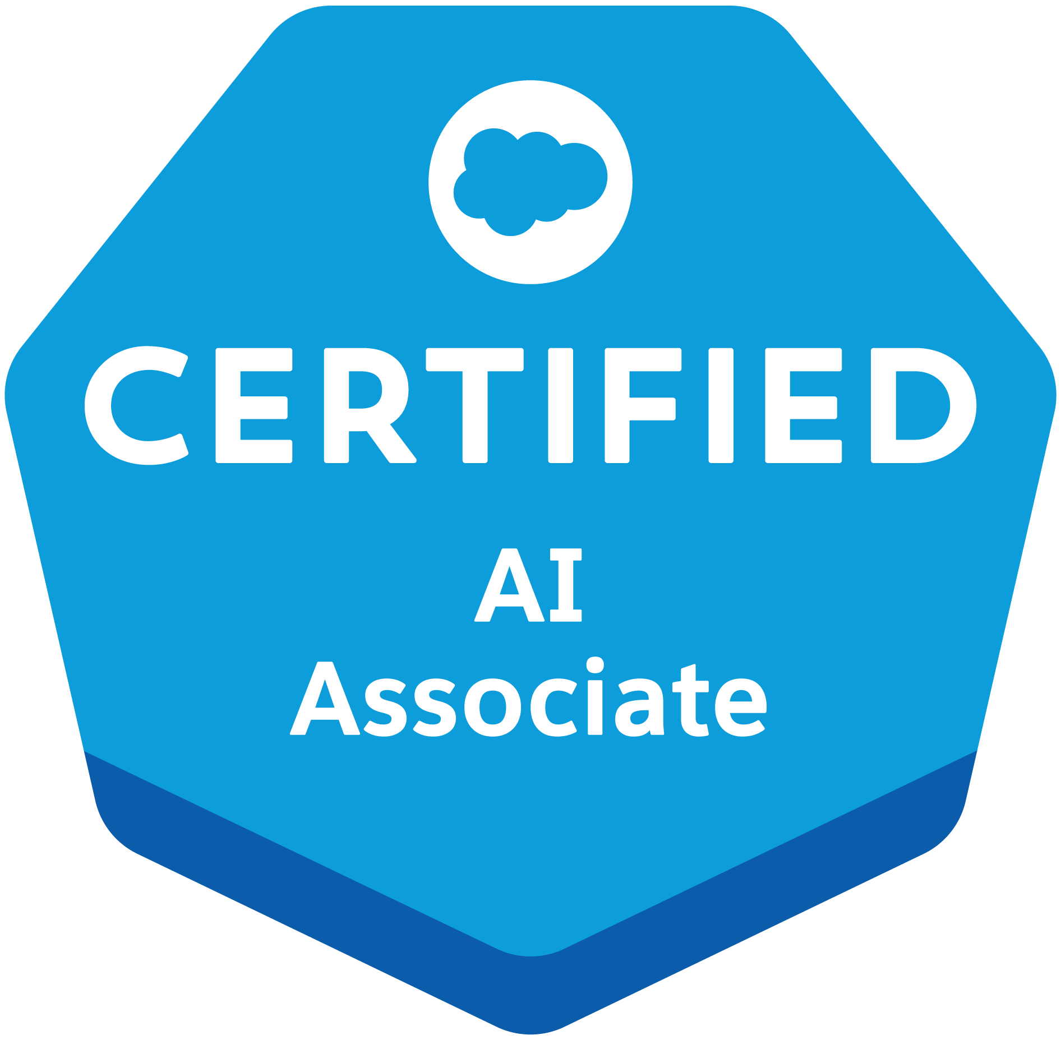
9607357648 | nikhilaksatpute@gmail.com | https://www.linkedin.com/in/nikhilasatpute | https://www.salesforce.com/trailblazer/amdit
PROFESSIONAL SUMMARY
Highly skilled and experienced Salesforce developer with a strong background in building and customizing Salesforce applications. Possesses expertise in various Salesforce technologies, including HTML, CSS, Javascript, Process Builder, Workflow, Apex (including Apex Classes and Apex Triggers), Lightning Web Component, and Visualforce. The candidate is proficient in data modeling, Apex Data Loader, and data migration. Possesses strong knowledge of SOQL and are skilled in building effective and informative dashboards and reports to help businesses make data-driven decisions.
EXPERIENCE
Salesforce Developer : Percept Infosystems Nagpur July 2023 - June 2024

- Project: Development of a Cloud-Based Insurance Platform for MS Amlin
- Technologies Used: Salesforce Sales Cloud, Apex, Visualforce, Lightning Web Components (LWC), SOQL, Salesforce Reports and Dashboard.
- Responsibilities:
  - Designed and implemented custom objects, fields, and relationships to store insurance agency details, customer information, and application data.
  - Developed a user-friendly interface using Lightning Web Components (LWC) to enable customers to search and view applications, and sales officers to manage customer data
  - Implemented business logic using Apex programming language to enforce data validation, prevent duplicate records, and ensure data integrity
  - Integrated with third-party APIs using API callouts to verify mobile numbers and update customer status
  - Developed batch classes to update application records and wrote test classes to ensure data quality

Associate RF Engineer: AMDOCS ,PUNE January 2022 - December 2022

- Developed and executed a comprehensive fiber network drafting strategy, resulted in a 25% reduction in drafting errors and a 15% increase in drafting efficiency.
- Orchestrated the implementation of ARAMIS, FTTx, and FTTH fiber planning systems, resulted in a 40% reduction in deployment time and a 30% increase in project completion rate.
Application Engineer: ARTEMIS PVT. LTD. ,PUNE October 2021 - January 2022
- Exhibiting strong technical aptitude and application expertise resulting in optimized performance, continuous improvement recommendations and product innovation.
- Partnered with the development team on product development and application support plans. Visited clients to determine feasibility, analyze requirements and provide solution suggestions.

Skills
- Salesforce Technologies: Salesforce Sales Cloud, Apex, Visualforce, Lightning Web Components (LWC), SOQL, Salesforce Reports and Dashboards
- Support Platforms: ServiceNow,REST Api,
- Programming Languages: Apex,HTML, CSS, JavaScript (for LWC), SQL,.NET,JAVA
- Tools: Salesforce Data Loader, JIRA,Agile, Excel,
- Project Management: Requirement Gathering, Process Improvement

CERTIFICATIONS
● Platform Developer I, Trailhead (2023)
● Salesforce Certified Associate, Trailhead (2023)
● Salesforce Certified AI Associate, Trailhead (2024)

Education

B.E. Electrical | Jspm’s RSCOE, Pune | 7.57 CGPA | 2021
Class XII, HSC | ACS college Chandrapur | 67.69% | 2017
Class X, CBSE | BJM Carmel academy, Chandrapur | 8.8 CGPA | 2015

